BRAC University
Department of Computer Science and Engineering
CSE 110 (Programming Language I)

Summer – 2007
Lab 1
Open Dr. Java:

On the Desktop, you should see an icon for DrJava (it looks like a big "J"). Double click on it. The main window of DrJava is broken up into three panes. On the left, you should a narrow pane containing the word "(Untitled)." There is a large pane to the right of that, which is where you should type your program. At the bottom of the window is a pane with three tabs "Interactions", "Console", and "Compiler Output."

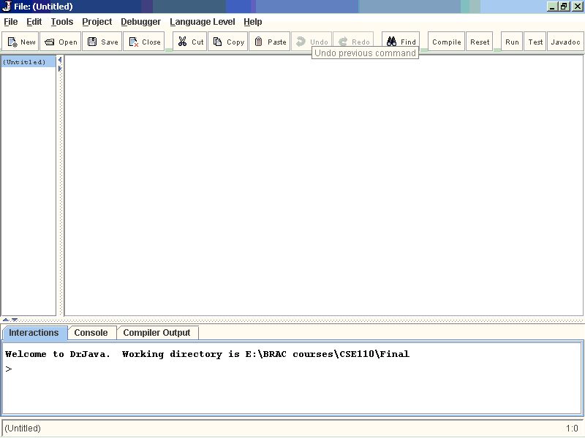

Write Java statements in the Interactions pane:

Click on the "Interactions" tab in the bottom pane. This is a great feature of Dr. Java.
Here, you can type any Java expression and DrJava will instantaneously compile, interpret, and evaluate it. Try it by typing the following Java expressions. Type them in exactly as shown, including the quotation marks. Record the result of the interaction on the worksheet at the end of this document.

- 3
- 3+5
- 4/6
- 4.0/6
- 9 - 4 * 3
- (9 - 4) * 3
- 3 /4 * 2
- "hello" + "goodbye"
- "3" + "5"
- "3 + 5 is " + 3 + 5
- "3 + 5 is " + (3 + 5)
- Math.pow(2,3)
- Math.pow(15, 0.5)
- Math.sqrt(16) + 8.3
- Math.pow(2,3) + Math.sqrt(64)

You may be discouraged by Java's poor math skills in examples i and j. In fact, the "+" operator does different things depending on its arguments. If both arguments are numbers, it adds them; if either argument is a String of characters, it concatenates them into a single String. We will talk more about this in lecture latter. In the Interactions pane, you can also type more complex Java statements. For instance, to write "Hello World" to the console, we can use the println method. Type the following in the Interactions pane:

System.out.println("Hello World");

Now print your name to the console. Click on the Console tab and you should see:

Hello World

For most of the programs that you write in this class, the output of your program will be a series of statements printed to the console.

Try to print you name following the previous method.

Write your first program:

Your first program will be a simple one: it prints "Hello World!" to the console.
Create a class called HelloWorld which System.out.println("Hello World!"); As a template, here is a class called HelloBRACU which prints "Hello BRAC University!" to the console. The class has one method called main. Inside the body of main, there is a single statement, a call to the println method of the System.out object (We will discuss about classes and objects more in class lectures). Change the name of this class to HelloWorld and also change what it prints to the screen. Also, change the author listed in the comment at the top of the program.

// My first program
// Author: Matin Abdullah
public class HelloBRACU {
public static void main(String[] args) {
System.out.println("Hello BRAC University!");
}
}

Save your program to a file on the Desktop with the filename
HelloWorld.java
Note: Java requires that the file name match the name of the class defined in the file.
Click the “Compile” button (or under the Tools menu, select "Compile All Documents"). Once DrJava has compiled your document, you should see the message Last compilation completed successfully. in the "Compiler Output" tab of the bottom window pane. Now if you look on the Desktop, you should see another file called HelloWorld.class

This file contains the bytecode into which your program was compiled. When you run your program, it is this bytecode that is interpreted by the Java virtual machine.
Now it is time to run your program. Go to Tools->Run Document's Main Method. Again in the bottom pane under the Interactions tab you should see:

Welcome to DrJava.
> java HelloWorld
Hello World!
>
Under the Console tab, you should see only: "Hello World!" Congratulations, you wrote your first of many programs in Java!

